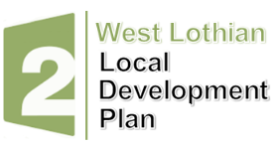

Development Plan Scheme and Participation Statement Review (2026)
Feedback Form

Please email your completed form to wlldp@westlothian.gov.uk

Q1 - Name of respondent / or if you are responding on behalf of a person, business or organisation

Q2 – Is Development Plan Scheme & Participation Statement (DPS) 2026 easy to understand?

Yes ☐ No ☐

If not, please explain why below.

Q3 – Are there aspects of the DPS that we could improve?

Yes ☐ No ☐

If yes, please explain below.

Q4 – Have you been involved in the early stages of the preparation of the council’s Local Development Plan (LDP) 2?

For example, through the preparation of a Local Place Plan, attending the ‘Let’s talk about LDP 2’ public drop in sessions, any discussions with planning officers etc.

Yes ☐ No ☐

If yes, please explain if you found the engagement to be useful.

Q5 – What ways could we better engage you or others in the LDP process?


Development Planning and Environment (DP&E)

